**Software Requirements Specifications (SRS)**

**ERP Solution for Lakhsma Sweater Ltd.**

REFERENCE: GW/ERP/SRS/

**Version: 1.0**

**Date of Release: September 23, 2015**



**Genweb2 Limited**

TK Bhaban (11th Floor),

13 Kazi Nazrul Islam Avenue,

Kawran Bazar, Dhaka 1215, Bangladesh

web: [http://www.genweb2.com](http://www.genweb2.com/)

**Contents**

Document Release History 4

1.0 Introduction 5

1.1 Purpose of SRS 5

2.0 Merchandising 6

2.1 Overview 6

2.2 Merchandising Process flow 6

3.0 Process Flow: 7

3.1 Receive style details: 7

3.2 Revise style details: 8

3.3 Request Quotation, Preparation Quotation and Approved Quotation: 9

3.4 Revise Quotation: 10

3.5 Sample requisition and submission: 11

3.6 Buyer order confirmation process: 12

3.7 Bill Of Materials (BOM): 13

4.0 USE CASE Diagram 14

4.1 Style process 14

4.2 Quotation Process: 14

4.3 Sample Process: 15

4.4 Export Order Process: 15

4.5 BOM Process: 16

5.0 USE CASE Details 17

5.1 UC/Mer/001/Receive Style: 17

5.2 UC/Mer/002/Confirm Style: 18

5.3 UC/Mer/003/Revise Style: 19

5.4 UC/Mer/004/Request Quotation: 20

5.5 UC/Mer/005/Identify Costs: 21

5.6 UC/Mer/006/Approve Quotation: 22

5.7 UC/Mer/007/Submit Quotation: 23

5.8 UC/Mer/008/Revise Quotation: 24

5.9 UC/Mer/009/Request Sample: 25

5.10 UC/Mer/010/Submit Sample: 26

5.11 UC/Mer/011/Request Rework: 27

5.12 UC/Mer/012/Receive Export Order (SO): 28

5.13 UC/Mer/013/Amend Export Order (SO): 29

5.14 UC/Mer/014/Create Consumption: 30

5.15 UC/Mer/015/Approve Consumption: 31

5.16 UC/Mer/016/Amend Consumption: 32

5.17 UC/Mer/017/Generate BOM: 33

5.18 UC/Mer/018/Regenerate BOM: 34

6.0 Merchandising mock-up 35

6.1 Merchandising master user interface mock-up 35

6.1.1 Buyer’s Departments: 35

6.1.2 Currency 36

6.1.3 Season 36

6.1.4 Size Group 37

6.1.5 Unit of measurement 37

6.2 Merchandising Operational user interface mock-up 38

6.2.1 Style 38

6.2.2 Sample requisition and submission 39

6.2.3 Pre-costing mock-up 40

6.2.4 Buyer work order 41

6.2.5 Materials Consumption 42

6.2.6 Bill Of Material (BOM) 43

Document Release History

| Sl. No. | Version Number | Release Date | Prepared By | Reviewed By | Approved By | Reasons for New Release |
| --- | --- | --- | --- | --- | --- | --- |
| 1 | 1.0 | 23rd Sep, 2015 | Nazifa Chowdhury |  | N/A |  |

# Introduction

## Purpose of SRS

The purposes of this SRS are to clearly identify the customer requirements and provide a detailed document. The customer will review the document and approve/make change as required. It will also help the review team to be able to validate whether the customer requirements has been fulfilled.

The SRS will also help the Analyst and Designer to understand and track the Requirements for the proposed system. It will also identify a set of requirements for the Development of the project. The SRS helps to describe the behavior of the system to be developed.

# Merchandising

## Overview

Merchandising is the heart of the Garments industries. Though the overall process of merchandising involves any sort of direct and indirect activities which is associated with any certain order given by buyer from inquiry to shipment but core activities are Quotation management, Sampling management, Consumption and Bill of Materials generation.

## Merchandising Process flow

Merchandising process flow consists:

* Receive Style Details
* Revise Style Details
* Request Quotation, Preparation Quotation and Approved Quotation
* Revise Quotation
* Sample Requisition and Submission:
* Buyer Order Confirmation Process
* Bill of Materials

# Process Flow:

## Receive style details:

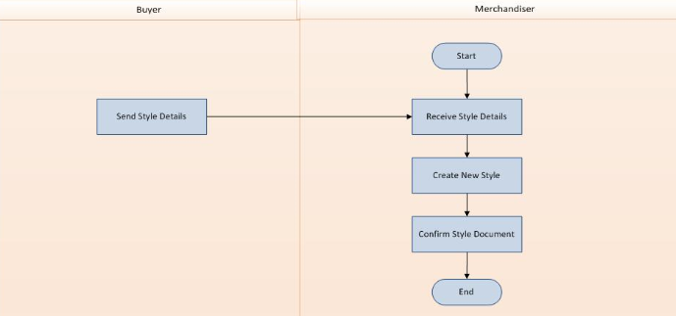

Fig: Receive style details

## Revise style details:

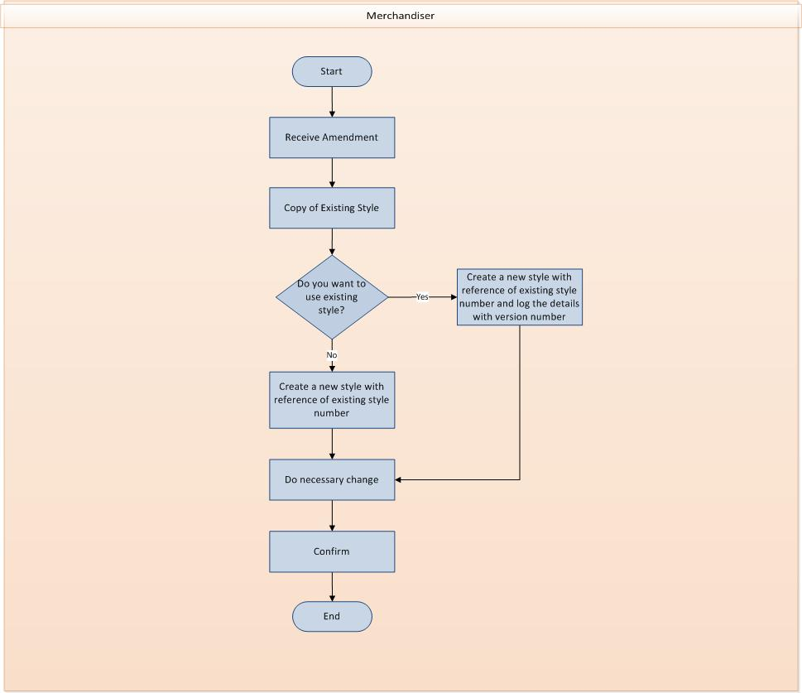

Fig: Revise style details

## Request Quotation, Preparation Quotation and Approved Quotation:

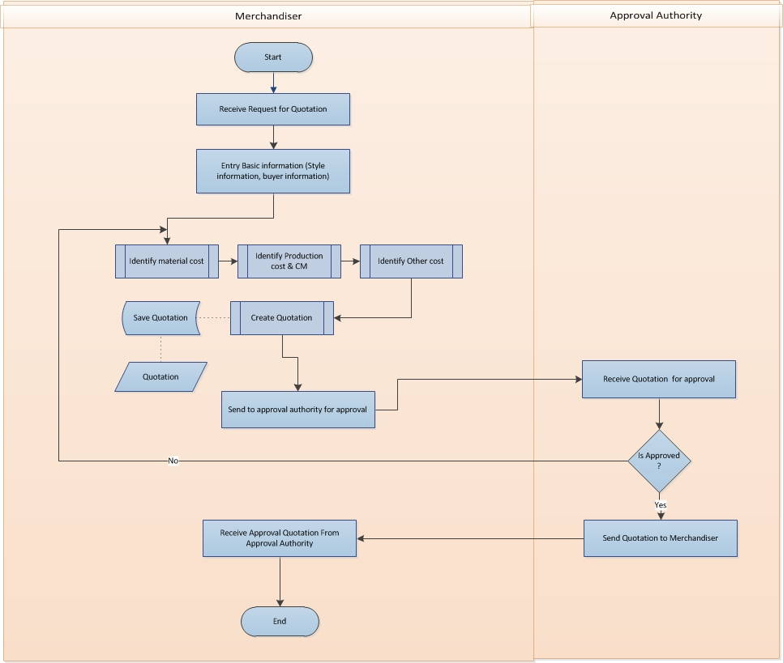

Fig: Request Quotation, Preparation Quotation and Approved Quotation

## Revise Quotation:

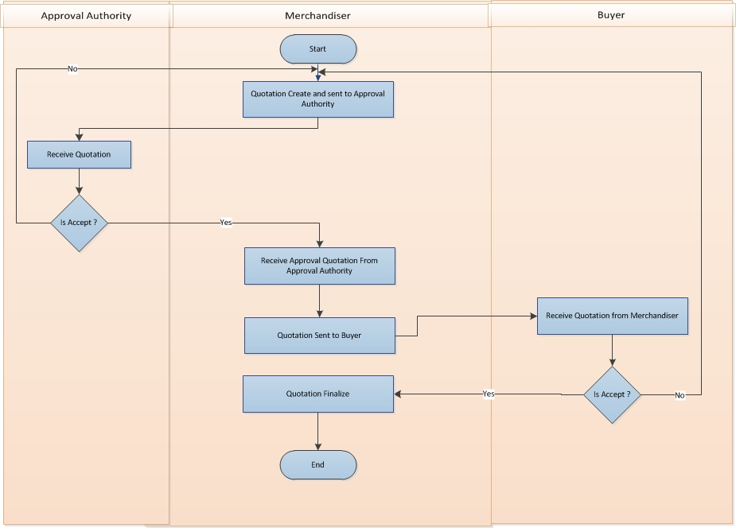

Fig: Revise quotation

## Sample requisition and submission:

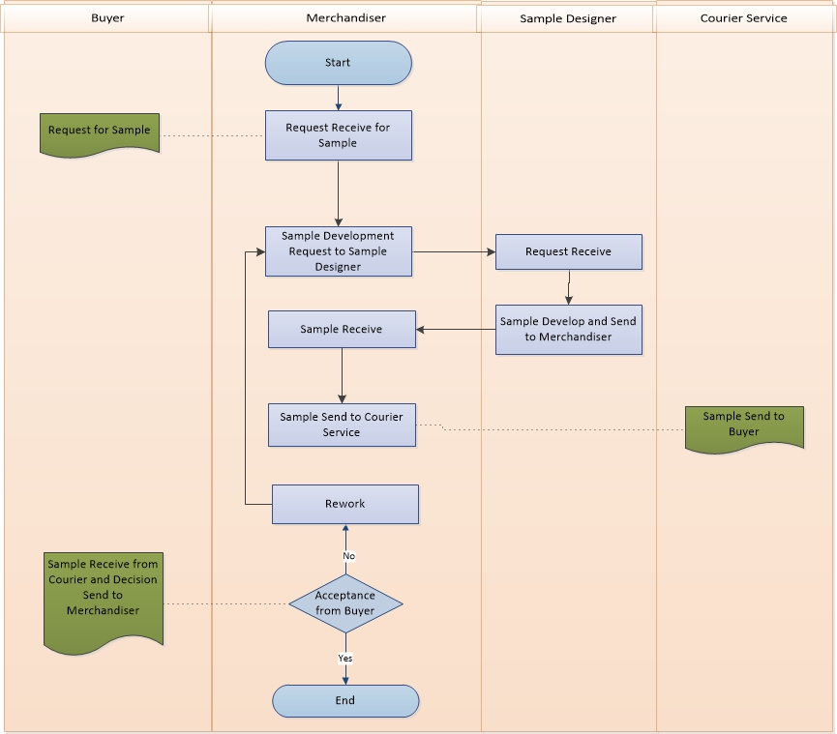

Fig: Sample requisition and submission process

## Buyer order confirmation process:

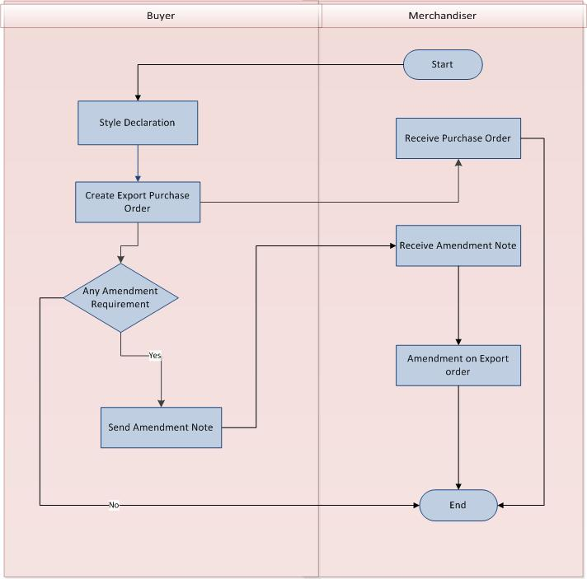

Fig: Buyer order confirmation process

## Bill Of Materials (BOM):

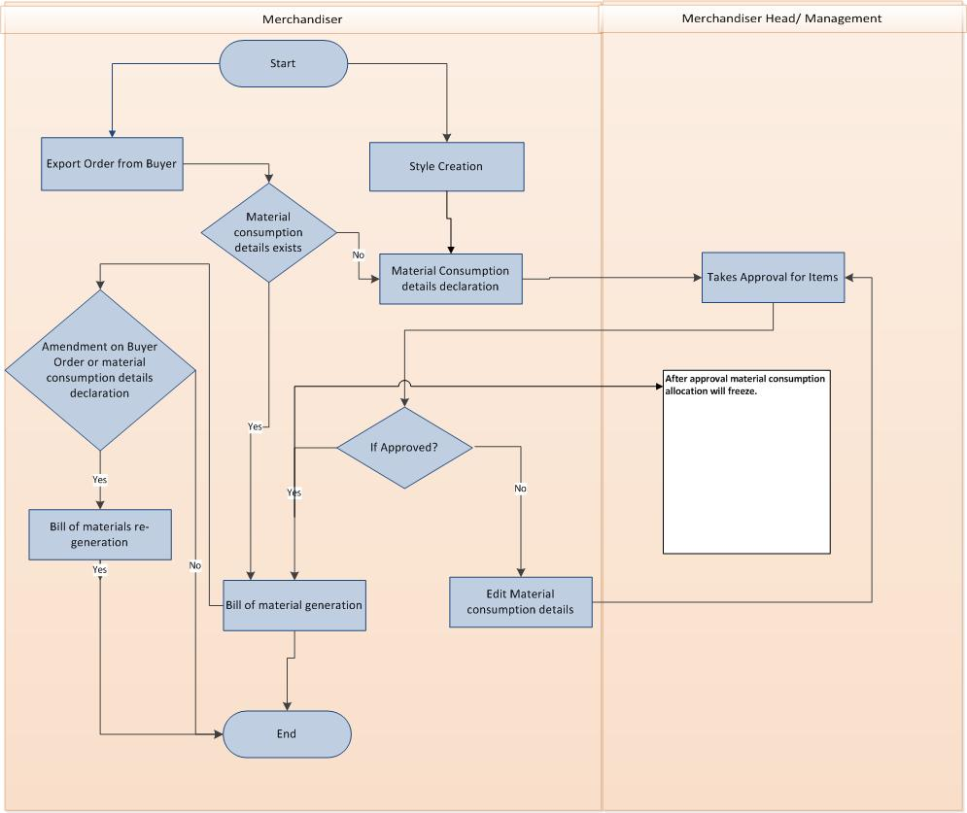

Fig: Bill Of Materials process

# USE CASE Diagram

## Style process

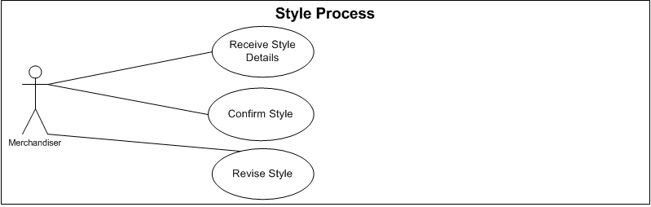

Fig: Style process use case

## Quotation Process:

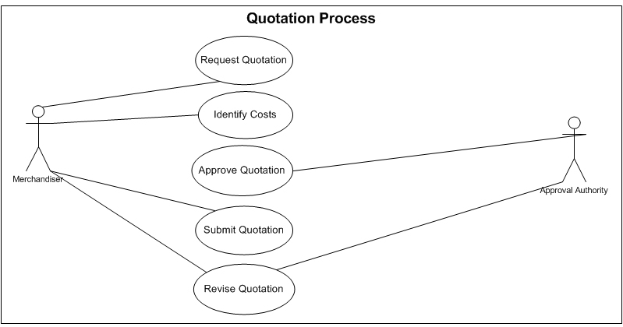

Fig: Quotation process use case

## Sample Process:

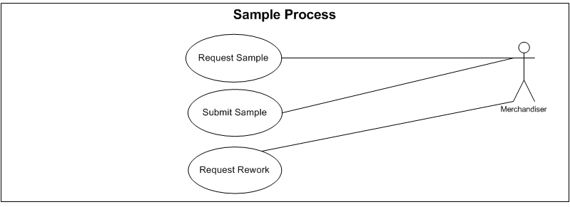

Fig: Sample process use case

## Export Order Process:

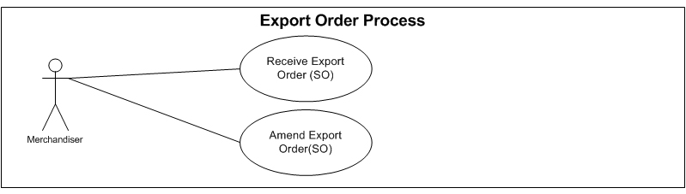

Fig: Export Order Process use case

## BOM Process:

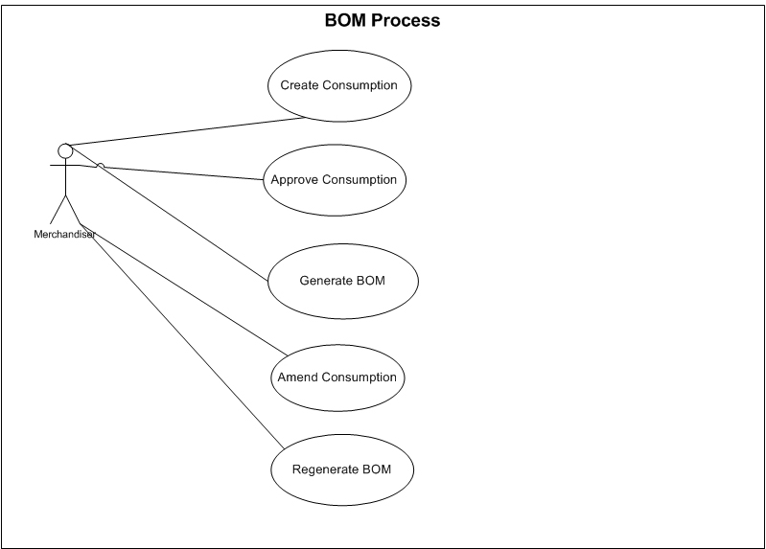

Fig: Bill Of Materials use case

# USE CASE Details

## UC/Mer/001/Receive Style:

|  |  |  |
| --- | --- | --- |
| Use Case ID: UC/Mer/001 | | |
| Use Case Name**: Receive Style** | | |
| Created By: **GenWeb2 Ltd.** | | Date Created: 22 September, 2015 |
| Actors: | * Merchandiser | |
| Trigger: | * When buyer sends new style | |
| Description: | When buyer send a new style details with technical specification, then merchandised will insert a new style in system. | |
| Frequency of Use | * Medium | |
| Preconditions | * Buyer must provide style specification. | |
| Post conditions | * N/A | |
| Assumption | * N/A | |
| Goal | Insert style details in system. | |
| Normal Flow | 1. Buyer prepares details specification of style and sends specification to Merchandiser. 2. Merchandiser receives style specification with all documents. 3. Merchandiser inserts all necessary information to create new style 4. Merchandiser submit style information to the system 5. System validates all information. 6. If submitted information are valid then system will save this new style information and also generate a new style number (auto generated style number) 7. If submitted information are not valid then system will display the error notification and keep the merchandised in same page | |
| Alternate Flow | * N/A | |
| Exception | * N/A | |
| Cross Reference | * N/A | |

## UC/Mer/002/Confirm Style:

|  |  |  |
| --- | --- | --- |
| Use Case ID: UC/Mer/002 | | |
| Use Case Name**: Confirm Style** | | |
| Created By: **GenWeb2 Ltd.** | | Date Created: 20 September, 2015 |
| Actors: | * Merchandiser | |
| Trigger: | * When Merchandiser wants to confirm any existing style information which is not confirmed yet. | |
| Description: | Merchandiser confirms an existing style. | |
| Frequency of Use | * Medium | |
| Preconditions | * Merchandiser must need to be authorized * Style information must need to be exist (Mer/UC/001) * Style information must not to be confirmed | |
| Post conditions | * N/A | |
| Assumption | * N/A | |
| Goal | Confirm style information to use in further process. | |
| Normal Flow | 1. Merchandiser log in to the system and select a style to confirm it 2. System check then authority of the merchandiser 3. If merchandiser is authorized, then system changes the selected style status as 'confirmed' | |
| Alternate Flow | * N/A | |
| Exception | * N/A | |
| Cross Reference | * UC/Mer/001 | |

## UC/Mer/003/Revise Style:

|  |  |  |
| --- | --- | --- |
| Use Case ID: UC/Mer/003 | | |
| Use Case Name**: Revise Style** | | |
| Created By: **GenWeb2 Ltd.** | | Date Created: 22 September, 2015 |
| Actors: | * Merchandiser | |
| Trigger: | * When Merchandiser wants to edit existing confirmed style information. | |
| Description: | Merchandiser edits existing style information and save it. | |
| Frequency of Use | * Low | |
| Preconditions | * Style information must need to be exist and confirmed | |
| Post conditions | * N/A | |
| Assumption | * N/A | |
| Goal | Update style information. | |
| Normal Flow | 1. Merchandiser receives an amendment to revise a 'Style' 2. Merchandiser selects that 'Style Information' to copy it    1. System opens a pop up and ask merchandiser whether s/he wants to use existing style number    2. If merchandiser wants to use existing style number, then s/he press 'yes' button. System creates a new style, by using selected style information and also keep style number same as it is and also system add a version number to this new style and log this.    3. If merchandiser wants new style number, then s/he press 'no' button. System creates a new style, by using selected style information and also generates a new style number. 3. Merchandiser makes necessary changes in new style information 4. Merchandiser saves this information to the system. 5. Merchandiser edits style information (if necessary) until confirm it 6. Merchandiser Confirms the Style 7. System saves style information, marks as 'Confirm' and freeze it | |
| Alternate Flow | * N/A | |
| Exception | * N/A | |
| Cross Reference | * UC/Mer/002 | |

## UC/Mer/004/Request Quotation:

|  |  |  |
| --- | --- | --- |
| Use Case ID: UC/Mer/004 | | |
| Use Case Name**: Request Quotation** | | |
| Created By: **GenWeb2 Ltd.** | | Date Created: **22 September 2015** |
| Actors: | Merchandiser, Buyer | |
| Trigger: | When Buyer ask the Quotation of any style | |
| Business Rule | Acknowledging Quotation request from Buyer | |
| Description: | 1. Buyer request to Merchandiser for Quotation 2. Merchandiser receive request for Quotation from Buyer | |
| Frequency of Use | High | |
| Preconditions | * Defining Style * Tech pack details | |
| Post conditions | * Identifying the cost | |
| Assumption | * Already in practice | |
| Goal | * Acknowledging request | |
| Normal Flow | 1. Buyer request to Merchandiser for Quotation 2. Merchandiser receive request for Quotation from Buyer | |
| Alternate Flow | * N/A | |
| Exception | * Cancel request | |
| Cross Reference | * N/A | |

## UC/Mer/005/Identify Costs:

|  |  |  |
| --- | --- | --- |
| Use Case ID: UCD/Mer/005 | | |
| Use Case Name**: Identify Costs** | | |
| Created By: **GenWeb2 Ltd.** | | Date Created: **22 September 2015** |
| Actors: | Merchandiser | |
| Trigger: | When Merchandiser receive the request for Quotation | |
| Business Rule | Pre cost calculation and Quotation finalization | |
| Description: | * Based on style and tech pack Merchandiser identify the cost * Merchandiser goes for every single elements to calculate the costing along with CM and Profit margin * Prepare quotation | |
| Frequency of Use | High | |
| Preconditions | * Defining Style * Quotation request from buyer | |
| Post conditions | * Quotation Approval | |
| Assumption | * Already in practice | |
| Goal | * Prepare Quotation | |
| Normal Flow | 1. Merchandiser receive style from buyer 2. Based on style and tech pack Merchandiser identify the cost of every element like material cost, other cost and CM 3. Prepare quotation | |
| Alternate Flow | * N/A | |
| Exception | * N/A | |
| Cross Reference | * UC/Mer/004 | |

## UC/Mer/006/Approve Quotation:

|  |  |  |
| --- | --- | --- |
| Use Case ID: UCD/Mer/006 | | |
| Use Case Name**: Approve Quotation** | | |
| Created By: **GenWeb2 Ltd.** | | Date Created: **22 September 2015** |
| Actors: | Merchandiser, Approval Authority | |
| Trigger: | When Merchandiser prepare Quotation | |
| Business Rule | Approve Quotation | |
| Description: | * After Prepare quotation, Merchandiser sent quotation to approval authority for approval * If the quotation is approved then send back * If the quotation is not approved then Merchandiser modify the quotation and resubmits for approval * Modification process will continue until the Quotation is approved | |
| Frequency of Use | High | |
| Preconditions | * Quotation must be exist | |
| Post conditions | * Modify Quotation (if not approved) * Submit Quotation to Buyer (if approved) | |
| Assumption | * Already in practice | |
| Goal | * Validate the Quotation by Approval Authority | |
| Normal Flow | 1. After Prepare quotation, Merchandiser sent quotation to approval authority for approval 2. Approved Quotation gets back to Merchandiser for submit to Buyer 3. Unapproved Quotation gets back to Merchandiser for modification and will be in approval process again. | |
| Alternate Flow | * N/A | |
| Exception | * N/A | |
| Cross Reference | * UC/Mer/005 | |

## UC/Mer/007/Submit Quotation:

|  |  |  |
| --- | --- | --- |
| Use Case ID: UC/Mer/007 | | |
| Use Case Name**: Submit Quotation** | | |
| Created By: **GenWeb2 Ltd.** | | Date Created: **22 September 2015** |
| Actors: | * Merchandiser, Buyer | |
| Trigger: | * When Approval Authority any Quotation | |
| Business Rule | * Submitting any approved Quotation to Buyer against Quotation request | |
| Description: | * After approved the Quotation Merchandiser submit it to Buyer | |
| Frequency of Use | * High | |
| Preconditions | * Quotation must be approved | |
| Post conditions | * Approve by Buyer | |
| Assumption | * Already in practice | |
| Goal | * Submit the Quotation against the request | |
| Normal Flow | 1. After approved the Quotation Merchandiser submit it to Buyer | |
| Alternate Flow | * N/A | |
| Exception | * N/A | |
| Cross Reference | * UC/Mer/006 | |

## UC/Mer/008/Revise Quotation:

|  |  |  |
| --- | --- | --- |
| Use Case ID: UC/Mer/008 | | |
| Use Case Name**: Revise Quotation** | | |
| Created By: **GenWeb2 Ltd.** | | Date Created: **22 September 2015** |
| Actors: | * Merchandiser, Approval Authority, Buyer | |
| Trigger: | * When Buyer ask any revision in Quotation | |
| Business Rule | * Revising the submitted Quotation | |
| Description: | * Buyer ask any revision in Quotation * Merchandiser revise the Quotation and sent to Approval Authority * Approval Authority can accept or reject the revised Quotation * If Approval Authority accept this Quotation then Merchandiser submit the revised Quotation to Buyer * If Buyer accept this Quotation then Merchandiser finalize this Quotation * If Buyer not accept this Quotation then Merchandiser again revise the Quotation and sent to Approval Authority for approval * It will continue base accepted or not | |
| Frequency of Use | * Medium | |
| Preconditions | * Submission of Quotation | |
| Post conditions | * Order confirmation, booking or cancellation by the buyer | |
| Assumption | * Already in practice | |
| Goal | * Addressing the revision | |
| Normal Flow | 1. Buyer ask any revision in Quotation 2. Concern Merchandiser address the revision request by Buyer and send to approval authority for further approval 3. Approval Authority can accept or reject the revised Quotation 4. If Approval Authority accept this Quotation then Merchandiser submit the revised Quotation to Buyer 5. If Approval Authority not approve the quotation then merchandiser modify the quotation and send for approval again. 6. If Buyer accept this Quotation then Merchandiser finalize this Quotation 7. If Buyer not accept this Quotation then Merchandiser again revise the Quotation and sent to Approval Authority for approval 8. It may continue based on approval and revision status | |
| Alternate Flow | * N/A | |
| Exception | Quotation may be cancelled | |
| Cross Reference | * UC/Mer/007 | |

## UC/Mer/009/Request Sample:

|  |  |  |
| --- | --- | --- |
| Use Case ID: UC/Mer/009 | | |
| Use Case Name**: Request Sample** | | |
| Created By: **GenWeb2 Ltd.** | | Date Created: **22 September, 2015** |
| Actors: | Merchandiser  Buyer | |
| Trigger: | When buyer request for any sample | |
| Description: | Buyer prepares details specification of sample item and sends specification to Merchandiser. Merchandiser receives sample item specification with all instruction documents. | |
| Frequency of Use | High | |
| Preconditions | * Buyer must provide both technical and design details. | |
| Post conditions | * N/A | |
| Assumption | * N/A | |
| Goal | Acknowledging the sample request and develop the sample accordingly. | |
| Normal Flow | 1. Buyer prepares details specification of sample item and sends specification to Merchandiser. 2. Merchandiser receives sample item specification with all documents. | |
| Alternate Flow | * N/A | |
| Exception | * N/A | |
| Cross Reference | * N/A | |

## UC/Mer/010/Submit Sample:

|  |  |  |
| --- | --- | --- |
| Use Case ID: UC/Mer/010 | | |
| Use Case Name**: Submit Sample** | | |
| Created By: **GenWeb2 Ltd.** | | Date Created: **22 September, 2015** |
| Actors: | Merchandiser  Buyer  Sample Designer  Courier Service | |
| Trigger: | When Merchandiser submit any sample against the sample request. | |
| Description: | Merchandiser receives the developed sample and submits that sample to Buyer against the sample request. | |
| Frequency of Use | High | |
| Preconditions | * Sample request from Buyer. | |
| Post conditions | * N/A | |
| Assumption | * N/A | |
| Goal | Submit the sample to Buyer as per request. | |
| Normal Flow | 1. Merchandiser sends sample specification to Designer for creates a sample item. 2. Designer prepares a sample item and sends the sample item to Merchandiser. 3. Merchandiser receives the sample item and sends to Buyer by Courier or Hand to Hand. 4. Buyer receive sample item. Buyer approved sample item depends on some condition- 5. Sample Item Receive: if sample item matched by buyer specification and there is no amendment, sample approval send to Merchandiser. 6. Sample Item Rework: if any amendment or any mismatch with specification then buyer sends the sample with necessary amendment for rework. | |
| Alternate Flow | * N/A | |
| Exception | * N/A | |
| Cross Reference | * UC/Mer/009 | |

## UC/Mer/011/Request Rework:

|  |  |  |
| --- | --- | --- |
| Use Case ID: UC/Mer/011 | | |
| Use Case Name**: Request Rework** | | |
| Created By: **GenWeb2 Ltd.** | | Date Created: **22 September, 2015** |
| Actors: | Merchandiser  Buyer  Sample Designer  Courier | |
| Trigger: | When Merchandiser receive rework order from Buyer for any submitted sample. | |
| Description: | When Merchandiser receives rework order from Buyer for any submitted sample and sends to sample designer. | |
| Frequency of Use | * Medium | |
| Preconditions | * Sample must be submitted | |
| Post conditions | * Re submission | |
| Assumption | * N/A | |
| Goal | Satisfy the sample rework request. | |
| Normal Flow | 1. If the submitted sample does not satisfy the Buyer then Buyer request with the necessary instruction for rework of that sample. 2. Merchandiser addresses the rework instruction and develops accordingly and sends to buyer. 3. Rework may continue until Buyer and Merchandiser comes to their satisfaction level. | |
| Alternate Flow | * N/A | |
| Exception | * N/A | |
| Cross Reference | * UC/Mer/010 | |

## UC/Mer/012/Receive Export Order (SO):

|  |  |  |
| --- | --- | --- |
| Use Case ID: UC/Mer/012 | | |
| Use Case Name**: Receive Export Order (SO)** | | |
| Created By: **GenWeb2 Ltd.** | | Date Created: **22 September, 2015** |
| Actors: | Merchandiser | |
| Trigger: | When Merchandiser receive export PO(sales order) from buyer | |
| Description: | Buyer gives the Export Purchase Order after quotation finalization. Export Order contains details Color and size wise order quantity, Unit of measurement, rate, Currency, Shipment Date, Shipment Destinations, Shipping Mode, HS Code, tolerance, Delivery Terms, Technical specification etc. | |
| Frequency of Use | Medium | |
| Preconditions | * Confirm style have to exist * Quotation have to be accepted by buyer | |
| Post conditions | * N/A | |
| Assumption | * N/A | |
| Goal | Create a sales order in the system | |
| Normal Flow | 1. Buyer gives the Export Purchase Order after quotation finalization. 2. Export Order contains details Color and size wise order quantity, Unit of measurement, rate, Currency, Shipment Date, Shipment Destinations, Shipping Mode, HS Code, tolerance, Delivery Terms, Technical specification etc. 3. Finalize the export purchase order | |
| Alternate Flow | * N/A | |
| Exception | * N/A | |
| Cross Reference | * N/A | |

## UC/Mer/013/Amend Export Order (SO):

|  |  |  |
| --- | --- | --- |
| Use Case ID: UC/Mer/013 | | |
| Use Case Name**: Amend Export Order(SO)** | | |
| Created By: **GenWeb2 Ltd.** | | Date Created: **22 September, 2015** |
| Actors: | Merchandiser | |
| Trigger: | When Merchandiser receive amendment/change request in export order from the buyer | |
| Description: | If merchandiser receive amendment note on export order from buyer then s/he incorporate those amendments in Export Purchase Order and proceed accordingly. | |
| Frequency of Use | * Medium | |
| Preconditions | * Buyer gives the amendment note to merchandiser | |
| Post conditions | * N/A | |
| Assumption | * N/A | |
| Goal | Address the buyer given amendment in sales order | |
| Normal Flow | 1. If there is any amendment in Export Purchase Order then concerned merchandiser receive amendment note from buyer. 2. Incorporate those amendments in Export Purchase Order. 3. Finalize the export purchase order | |
| Alternate Flow | * N/A | |
| Exception | * N/A | |
| Cross Reference | * UC/Mer/012 | |

## UC/Mer/014/Create Consumption:

|  |  |  |
| --- | --- | --- |
| Use Case ID: UC/Mer/014 | | |
| Use Case Name**: Create Consumption** | | |
| Created By: **GenWeb2 Ltd.** | | Date Created: **22 September, 2015** |
| Actors: | Merchandiser | |
| Trigger: | When merchandiser wants to create raw material consumption template for any style and/or export PO. | |
| Description: | Merchandiser declares the raw materials consumption of an ideal Finished Goods quantity based on style and/or Export PO. | |
| Frequency of Use | Medium | |
| Preconditions | * Style and/or Export PO must exist | |
| Post conditions | * N/A | |
| Assumption | * N/A | |
| Goal | Define raw materials consumption logic | |
| Normal Flow | 1. Merchandiser receive style from buyer 2. Merchandiser gets export order from buyer 3. Respective Merchandiser declares the raw materials consumption of an ideal Finished Goods quantity style and/or Export PO. | |
| Alternate Flow | * N/A | |
| Exception | * Ideal raw materials consumption can be done based on Export PO * Ideal raw materials consumption can be done based on both style and Export PO | |
| Cross Reference | * UC/Mer/002 | |

## UC/Mer/015/Approve Consumption:

|  |  |  |
| --- | --- | --- |
| Use Case ID: UC/Mer/015 | | |
| Use Case Name**: Approve Consumption** | | |
| Created By: **GenWeb2 Ltd.** | | Date Created: **22 September, 2015** |
| Actors: | * Approval Authority | |
| Trigger: | When approval authority wants to approve any raw materials consumption template | |
| Description: | Merchandiser will take consumption approval from authority. After approval declared items and quantity will be freeze. | |
| Frequency of Use | Medium | |
| Preconditions | * Defined consumption allocation | |
| Post conditions | * N/A | |
| Assumption | * N/A | |
| Goal | Freeze the item and quantity in consumption template | |
| Normal Flow | 1. Merchandiser will create raw material consumption template 2. Approval authority will approved the raw material consumption template 3. After approval consumption ratio will be freeze. | |
| Alternate Flow | * N/A | |
| Exception | * N/A | |
| Cross Reference | * UC/Mer/014 | |

## UC/Mer/016/Amend Consumption:

|  |  |  |
| --- | --- | --- |
| Use Case ID: UC/Mer/016 | | |
| Use Case Name**: Amend Consumption** | | |
| Created By: **GenWeb2 Ltd.** | | Date Created: **22 September, 2015** |
| Actors: | * Merchandiser | |
| Trigger: | When merchandiser wants to modify items and/or quantity in consumption template | |
| Description: | Merchandiser will modify the raw materials requirements in consumption template so it will be reflected in bill of materials (BOM) accordingly | |
| Frequency of Use | Medium | |
| Preconditions | * Consumption template must be exist | |
| Post conditions | * Have to be get approved | |
| Assumption | * N/A | |
| Goal | Update raw materials requirements | |
| Normal Flow | 1. Merchandiser will modify the raw material consumption template if any items need to be replaced 2. Merchandiser will modify the raw material consumption template if any items consumption quantity get changed 3. Consumption template will go through the approval procedure and it will reflect in BOM (generate/regenerate) | |
| Alternate Flow | * N/A | |
| Exception | * N/A | |
| Cross Reference | * UC/Mer/014 | |

## UC/Mer/017/Generate BOM:

|  |  |  |
| --- | --- | --- |
| Use Case ID: UC/Mer/017 | | |
| Use Case Name**: Generate BOM** | | |
| Created By: **GenWeb2 Ltd.** | | Date Created: **22 September, 2015** |
| Actors: | Merchandiser | |
| Trigger: | When approval authority approve the raw materials | |
| Description: | Considering the Export order quantity and Consumption logic, total raw materials and quantity will be generated for any certain PO/style. This process considers the shipment tolerance and wastage percentage. | |
| Frequency of Use | Medium | |
| Preconditions | * Export order must exist * Approved consumption template must exist | |
| Post conditions | * N/A | |
| Assumption | * N/A | |
| Goal | Generate total raw materials requirement for any certain export order | |
| Normal Flow | 1. Merchandiser receive the export PO from buyer 2. Merchandiser declare raw materials consumption logic in consumption template 3. Merchandiser generate BOM considering the export PO and consumption template | |
| Alternate Flow | * N/A | |
| Exception | * N/A | |
| Cross Reference | * N/A | |

## UC/Mer/018/Regenerate BOM:

|  |  |  |
| --- | --- | --- |
| Use Case ID: UC/Mer/018 | | |
| Use Case Name**: Regenerate BOM** | | |
| Created By: **GenWeb2 Ltd.** | | Date Created: **22 September, 2015** |
| Actors: | Merchandiser | |
| Trigger: | When merchandiser needs to regenerate BOM (based on amendment in export order and/or consumption template) | |
| Description: | If Amendment on buyer orders and/or modification in consumption template take place after BOM generation then BOM will be regenerated. | |
| Frequency of Use | Medium | |
| Preconditions | * BOM must exist and amendment on export order and/or modification in consumption template. | |
| Post conditions | * N/A | |
| Assumption | * N/A | |
| Goal | To get the appropriate BOM item and quantity | |
| Normal Flow | 1. If Amendment on buyer orders which takes place after BOM generation then BOM will be regenerated. 2. If any item/quantity level changes take place in raw material consumption details then BOM will be regenerated. | |
| Alternate Flow | * N/A | |
| Exception | * N/A | |
| Cross Reference | * UC/Mer/017 | |

# Merchandising mock-up

## Merchandising master user interface mock-up

### Buyer’s Departments:

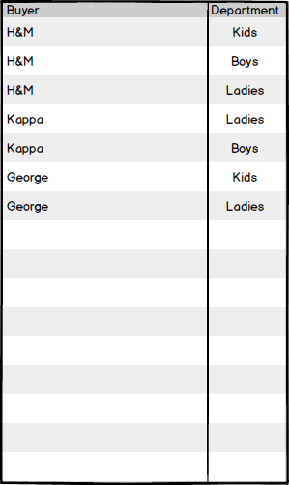

Fig: Buyer’s Department

### Currency

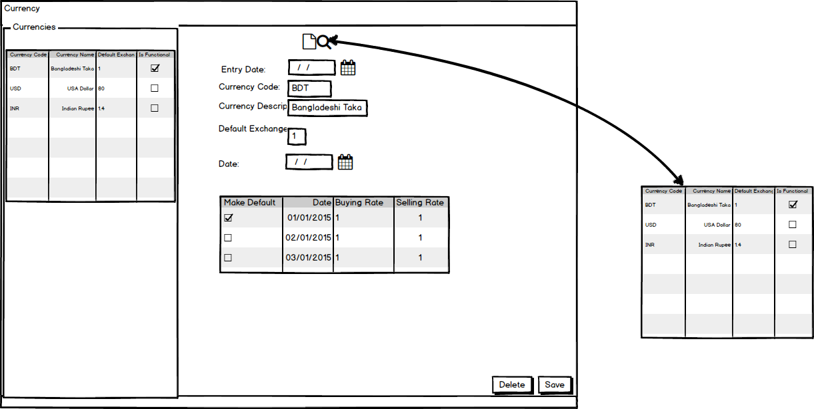

Fig: Currency

### Season

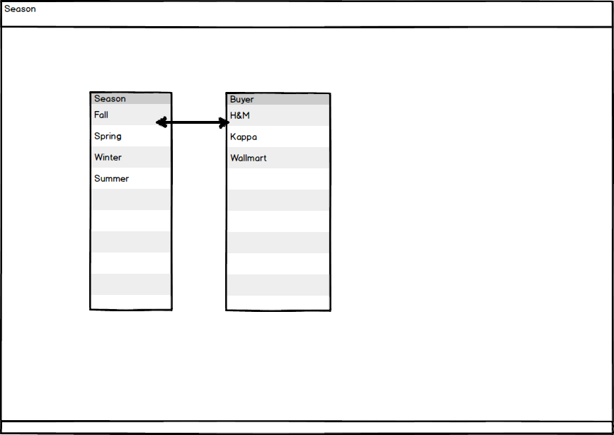

Fig: Season

### Size Group

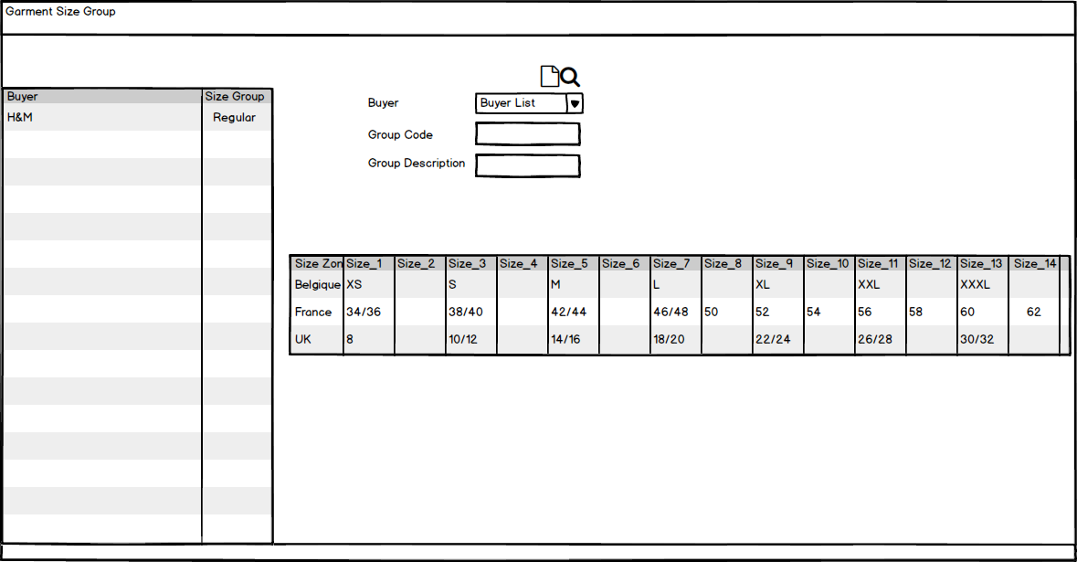

Fig: Size group

### Unit of measurement

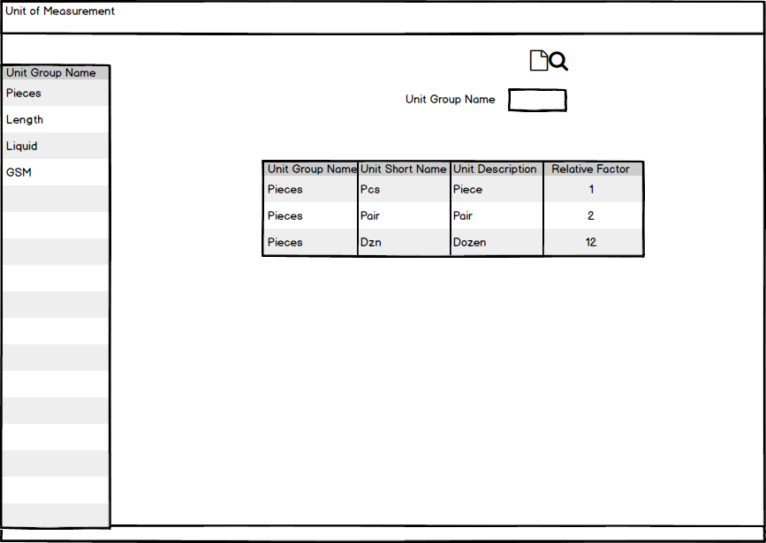

Fig: Unit of measurement

## Merchandising Operational user interface mock-up

### Style

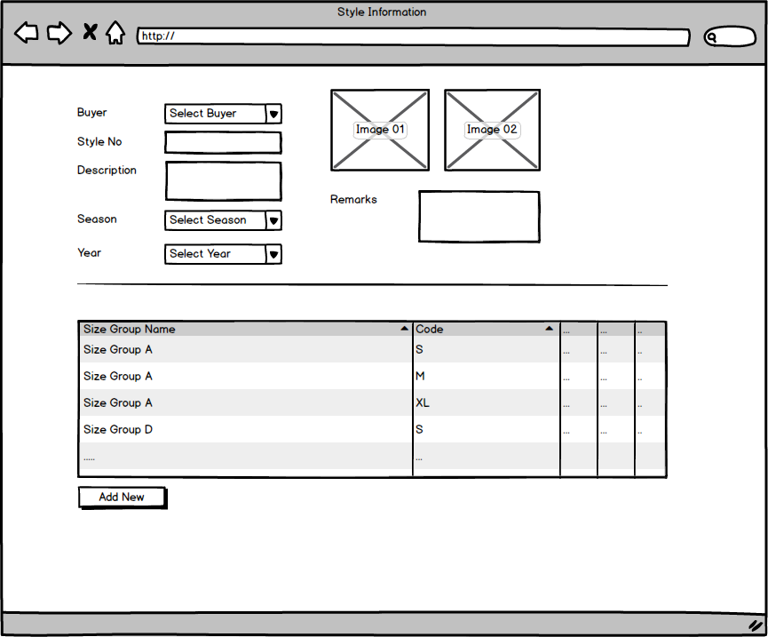

Fig: Style

### Sample requisition and submission

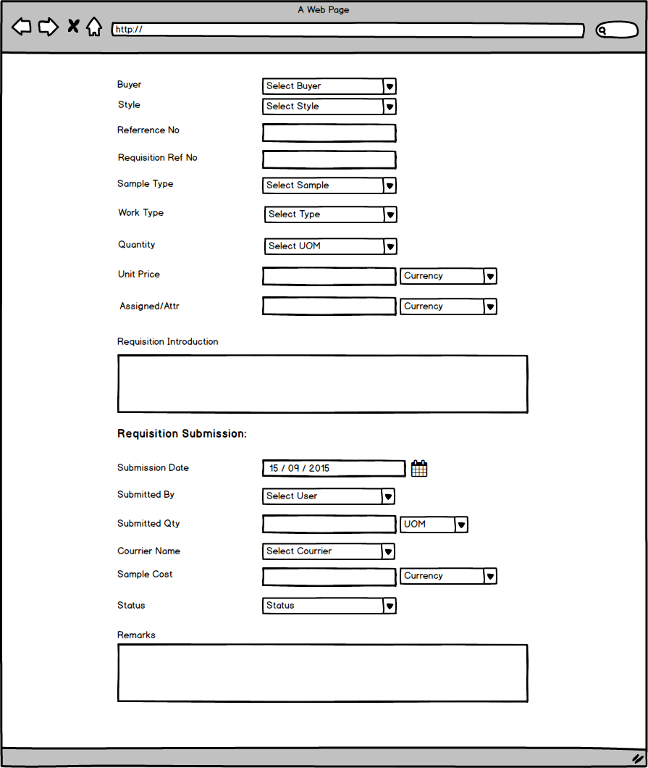

Fig: Sample requisition and submission

### Pre-costing mock-up

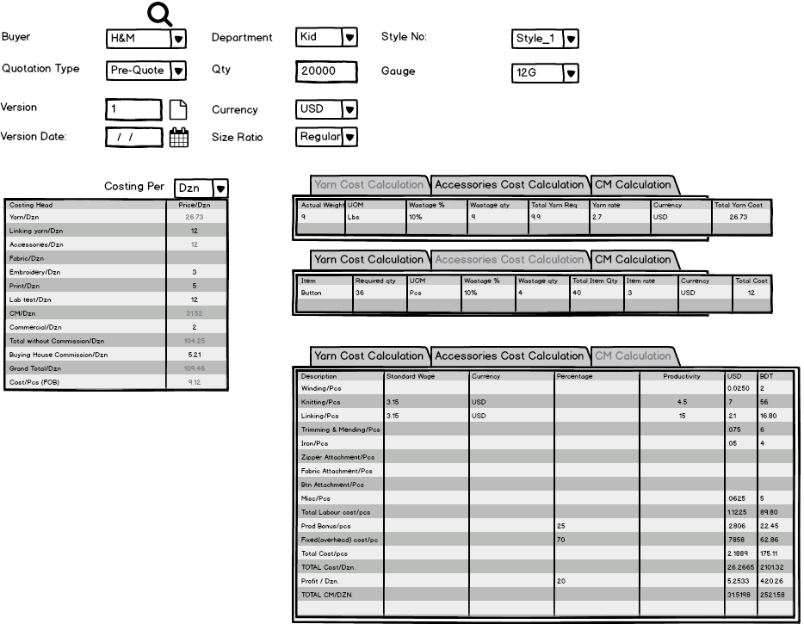

Fig: Pre-costing mock-up

### Buyer work order

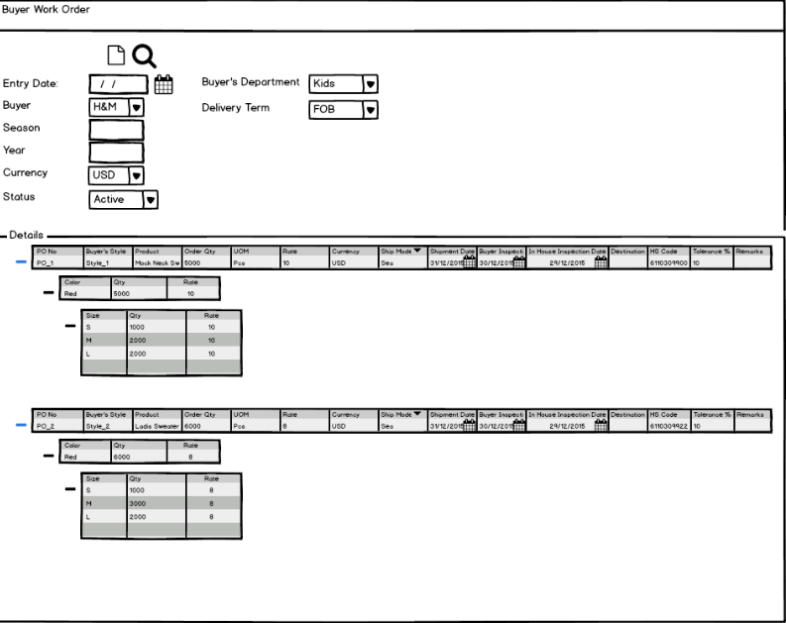

Fig: Buyer work order

### Materials Consumption

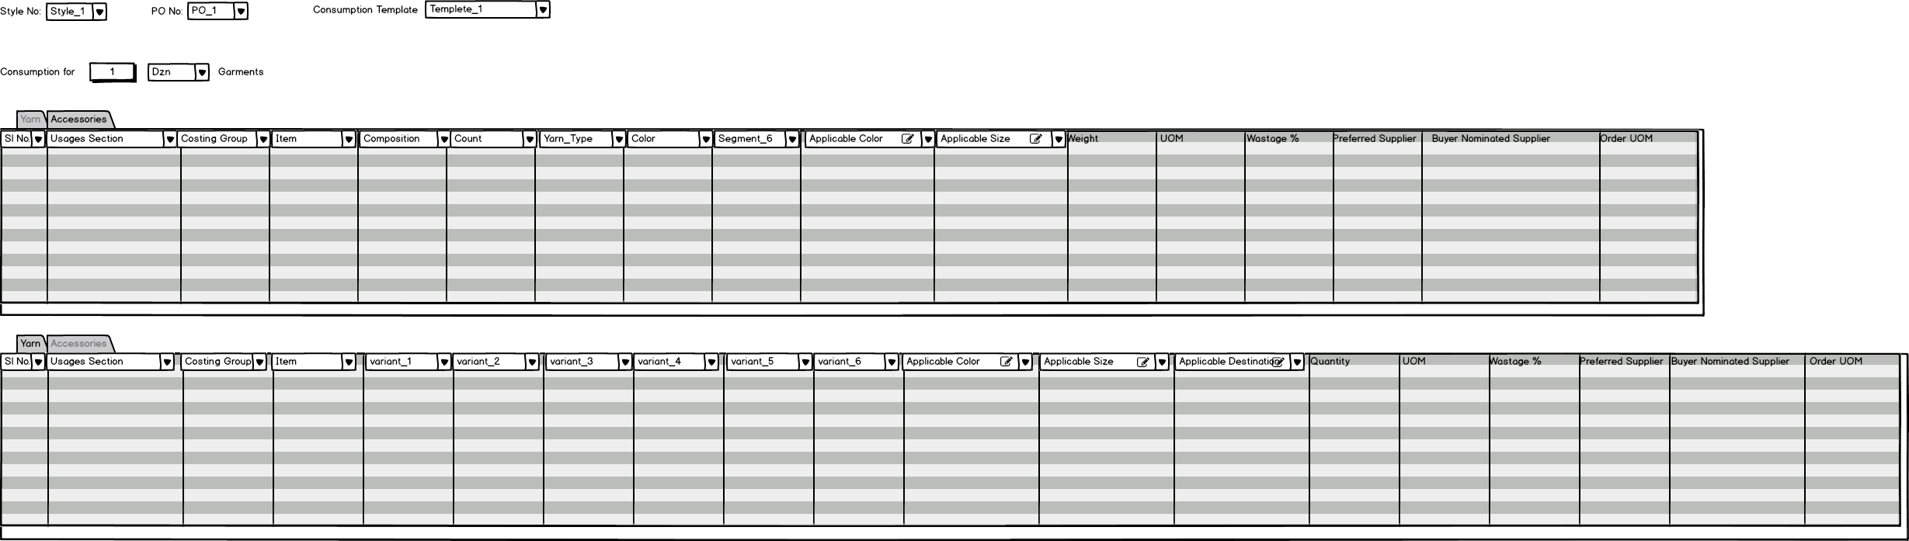

Fig: Material Consumption

### Bill Of Material (BOM)

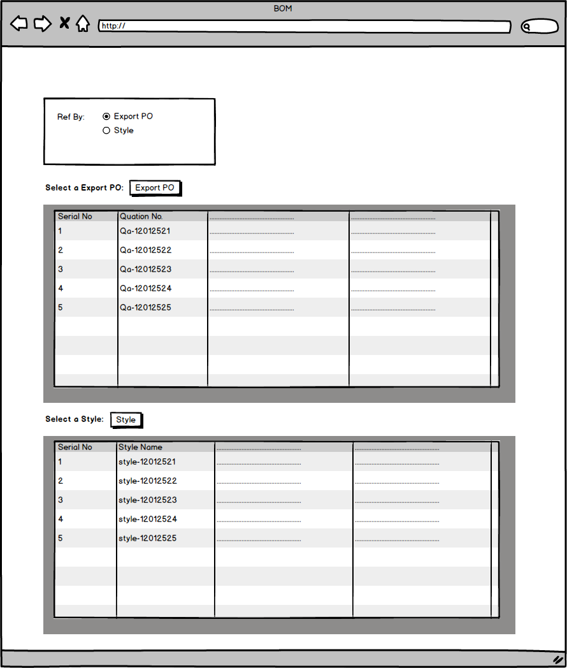

Fig: Bill Of Material (BOM)